PfC Assignment 2 – Logical Network Topology example and instructions

You will use the same format as below to develop the logical network topology.

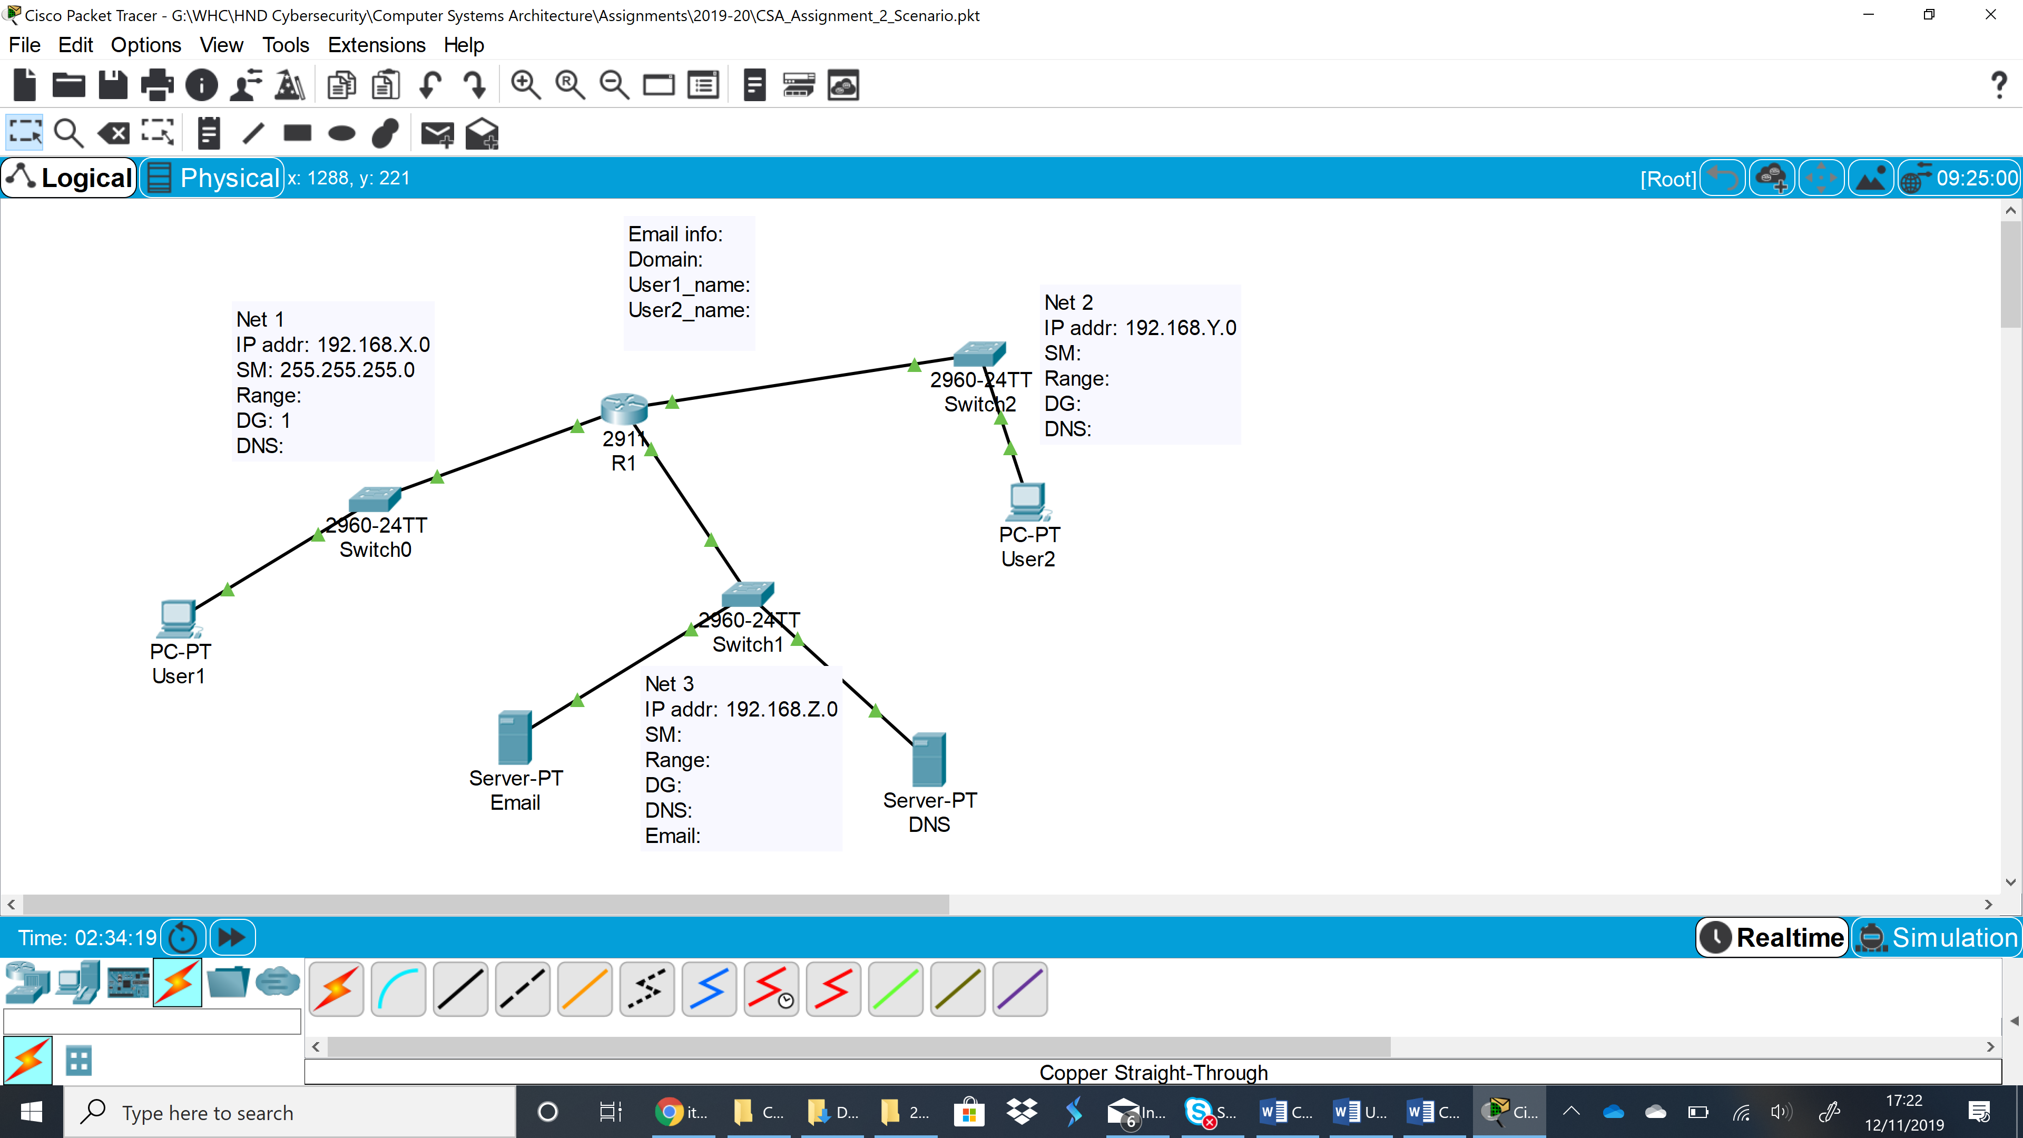

You are given a specific addressing scheme by your line manager (tutor) in a separate document. The IP addresses will be different for each of you. It is clear from the screenshot example above that there are IP addressing configuration parameters that you have to decide yourself what they can be. They have been left empty on purpose, because those parameters are for you to complete.

In the example above, there are only three networks. For your assignment, there will be more than three, of course, but you get the idea from here, what the logical topology will look like. There is only one router here, and you may need more than one router for your own topology, but now it is easy to apply the knowledge from here to your assignment.

You can start implementing the diagram on Packet Tracer, but your work does not actually start on Packet Tracer. It starts on paper, by deciding on the IP addressing parameters that are missing, and then creating the IP addressing scheme in table format. An example of IP address table is provided below, but you are invited to use it only as a guide. You might need to change the table structure to fit your purpose. An IP address table is detailed and complete, when another person that is tasked to implement your IP addressing scheme will not need to ask questions about what to configure where.

|  |  |  |  |  |  |
| --- | --- | --- | --- | --- | --- |
| Device | Interface | IP address | Subnet Mask | Default Gateway | DNS Server |
| Router R1 | Gi 0/0 | 192.168.10.1 | 255.255.255.0 | N/A | N/A |
| Router R1 | Gi 0/1 | ……. | ……… | ……. | ……. |
| PCs (Programmers) | Fa0 | 192.168.10.2-254 | 255.255.255.0 |  | 192.168.15.3 |
|  |  |  |  |  |  |

On Packet Tracer, you need to create the network, configure all the PCs, the servers, and the LAN interfaces on the router. The servers will be configured with the same services as per the diagram – Email and DNS. One of them is an Email server, and the other one is a DNS server. At least two users with names of your choice must be able to send emails to each-other. You have to plan your work first. Where would you start and what would you do first?

Wherever you start and whatever you decide to do first, when the PCs and server can ping their default gateways, then the initial IP configuration is implemented correctly.

Then, the other aspect of your work is the configuration of the other services – DNS, and Email. After services are configured correctly, then the clients can be configured. However, the order of your work is for you to decide.